1. How many trips have been recorded total during the chosen period?

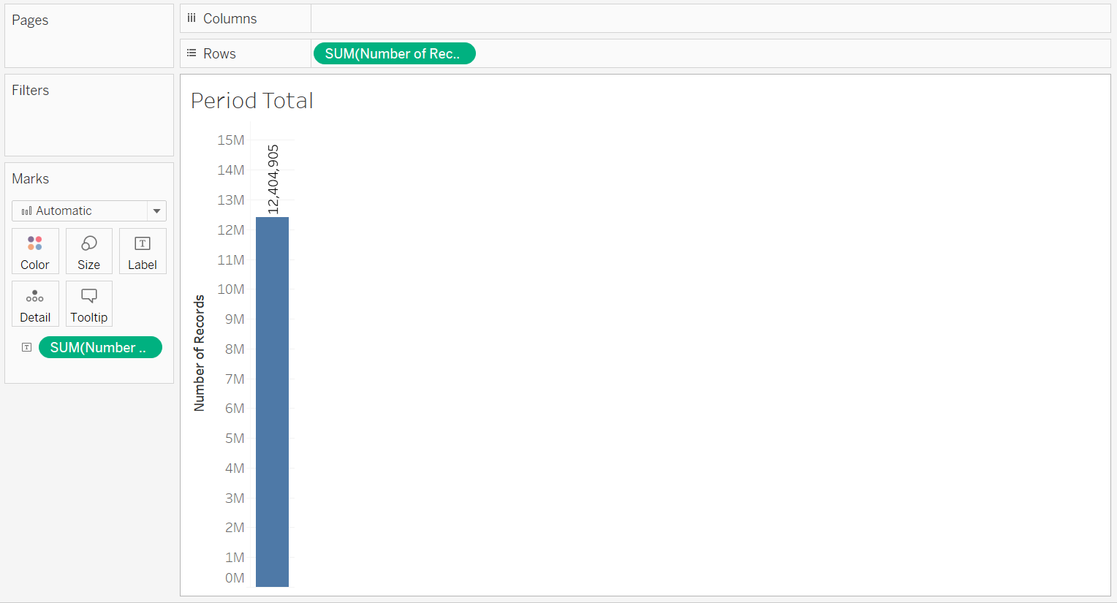

1. By what percentage has total ridership grown?

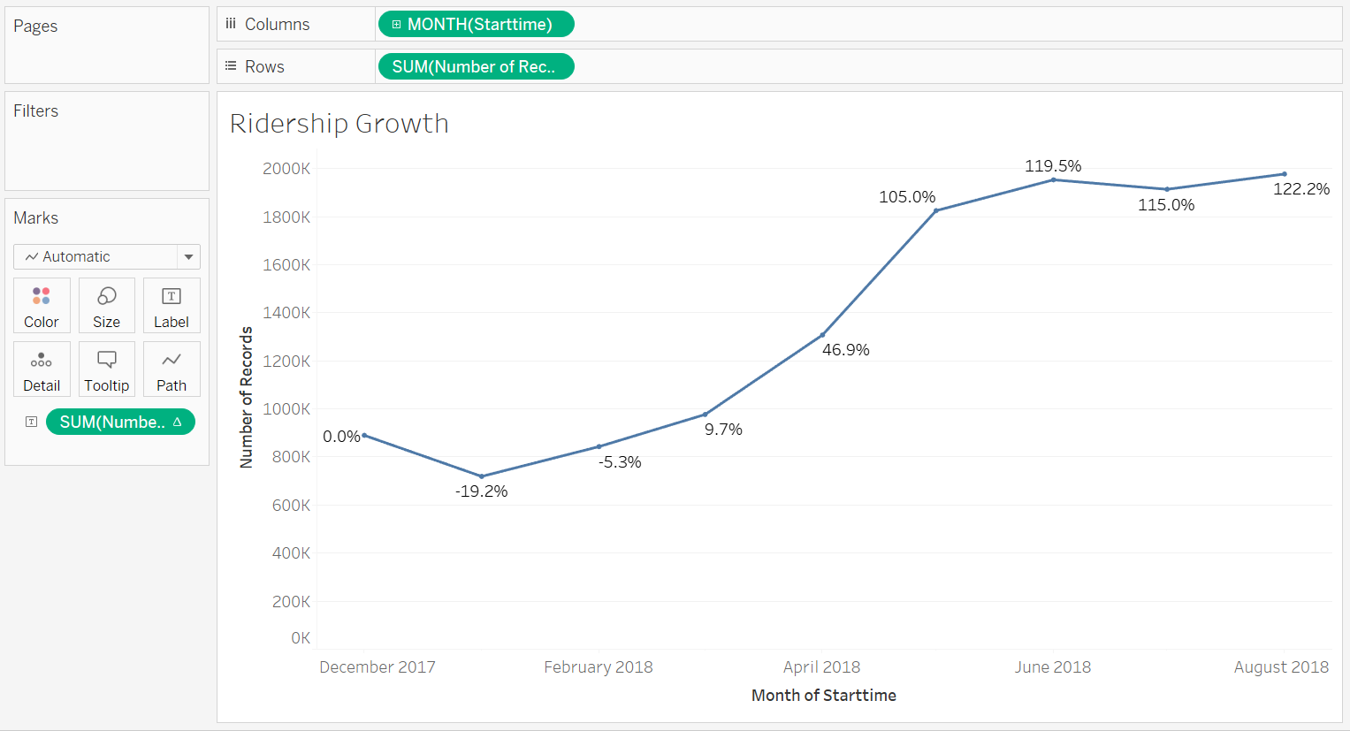

1. How has the proportion of short-term customers and annual subscribers changed?

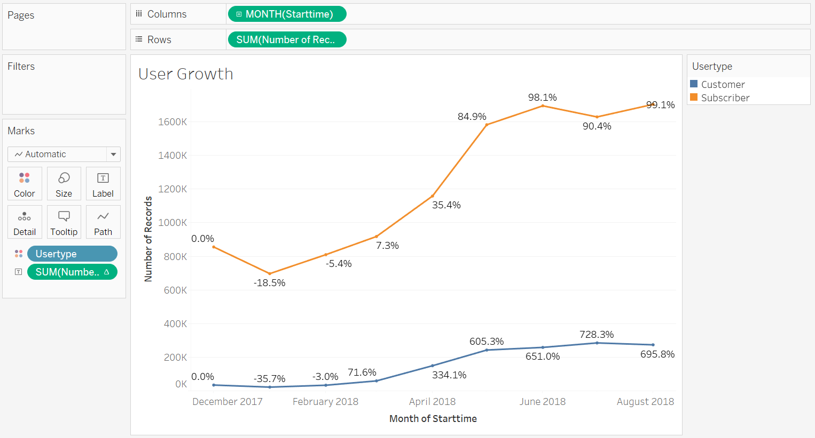

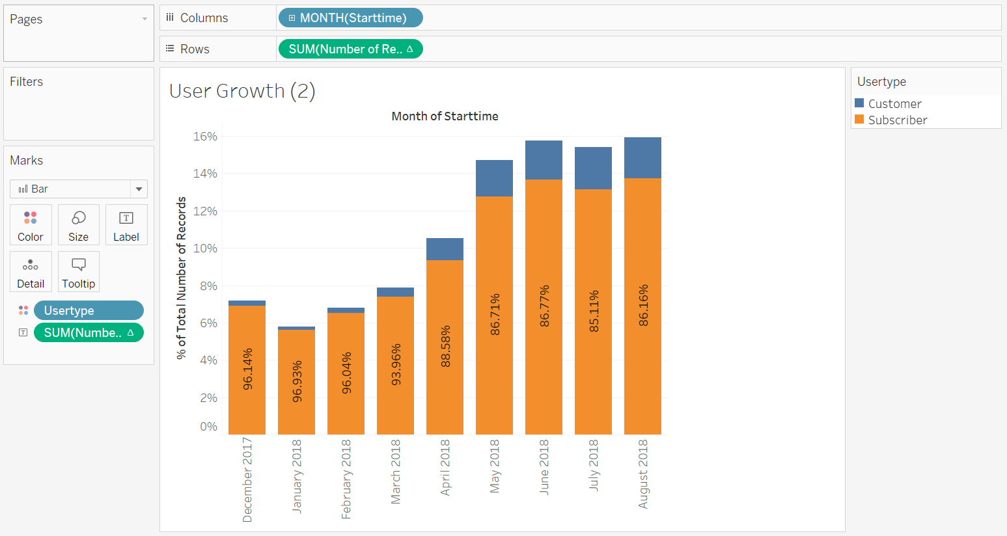

1. What are the peak hours in which bikes are used during summer months?

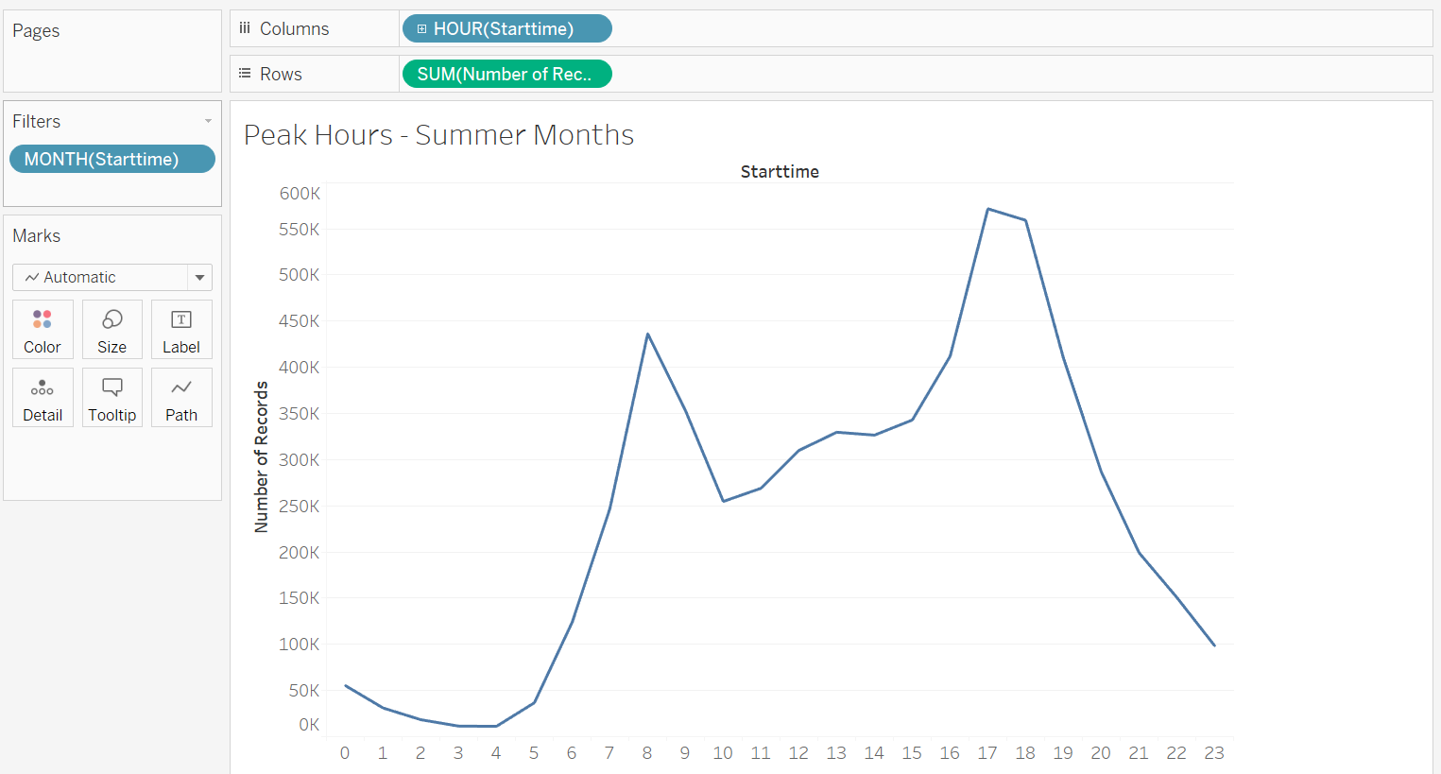

1. What are the peak hours in which bikes are used during summer months?

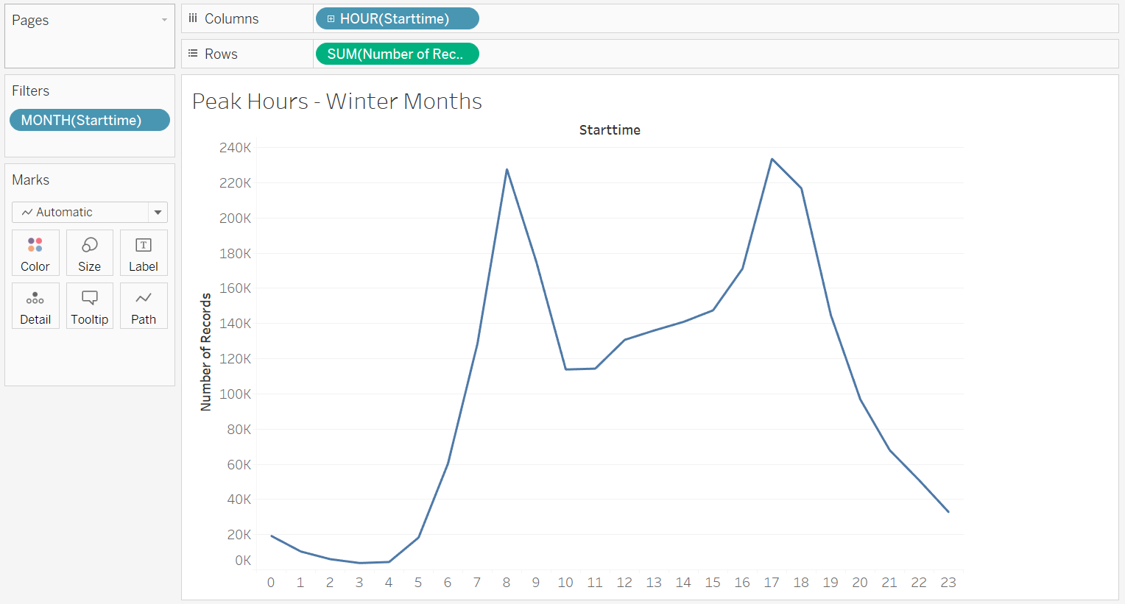

1. Today, what are the top 10 stations in the city for starting a journey? (Based on data, why do you hypothesize these are the top locations?)

Predicting the following starting stations based on the trends from the chart below. This prediction is only accurate for the few days after the last data points.

Pershing Square North

E 17 St & Broadway

West St & Chambers St

Broadway & E 22 St

W 21 St & 6 Ave

Broadway & E 14 St

8 Ave & w 31 St

South End Ave & Liberty St

8 Ave & W 33 St

Carmine St & 6 Ave

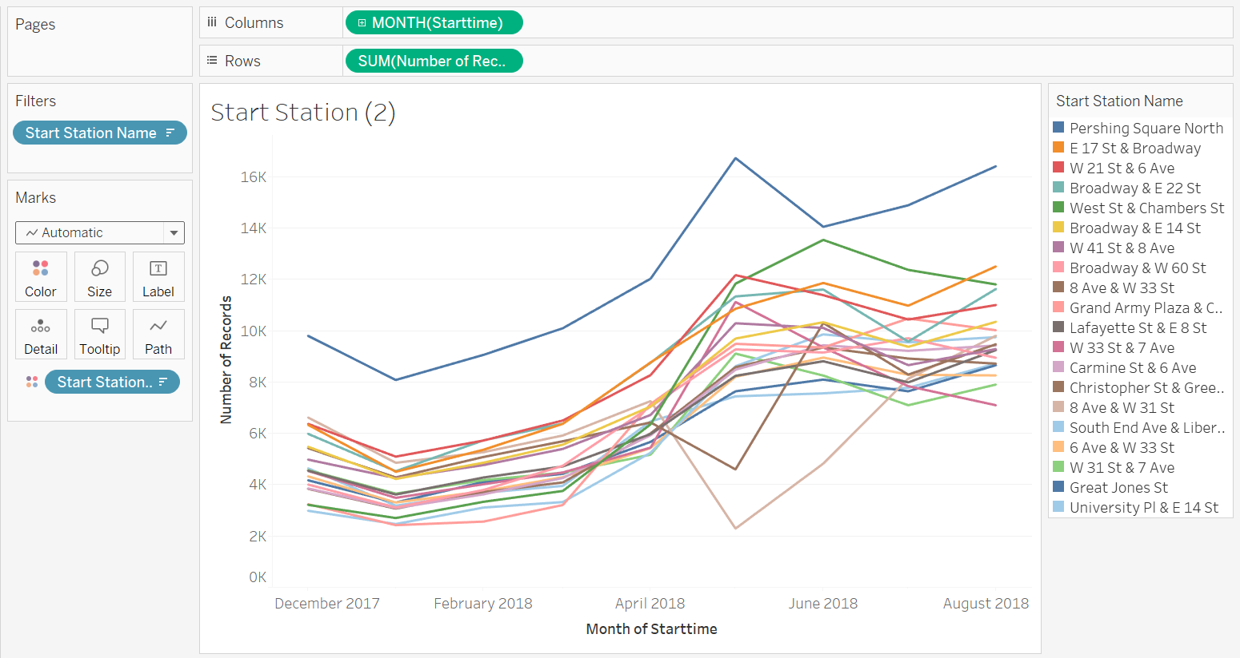

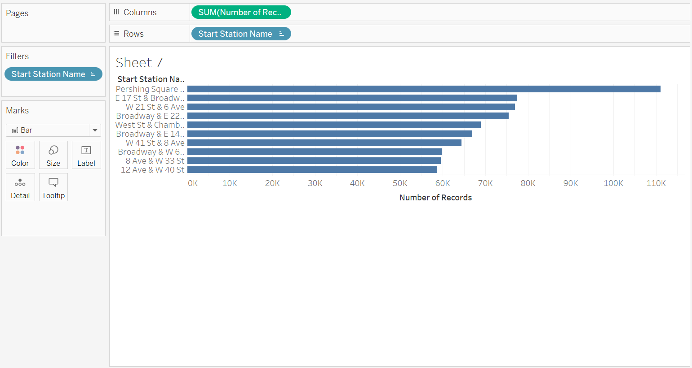

1. Today, what are the top 10 stations in the city for ending a journey? (Based on data, why?)
2. Today, what are the bottom 10 stations in the city for starting a journey? (Based on data, why?)
3. Today, what are the bottom 10 stations in the city for ending a journey (Based on data, why?)
4. Today, what is the gender breakdown of active participants (Male v. Female)?

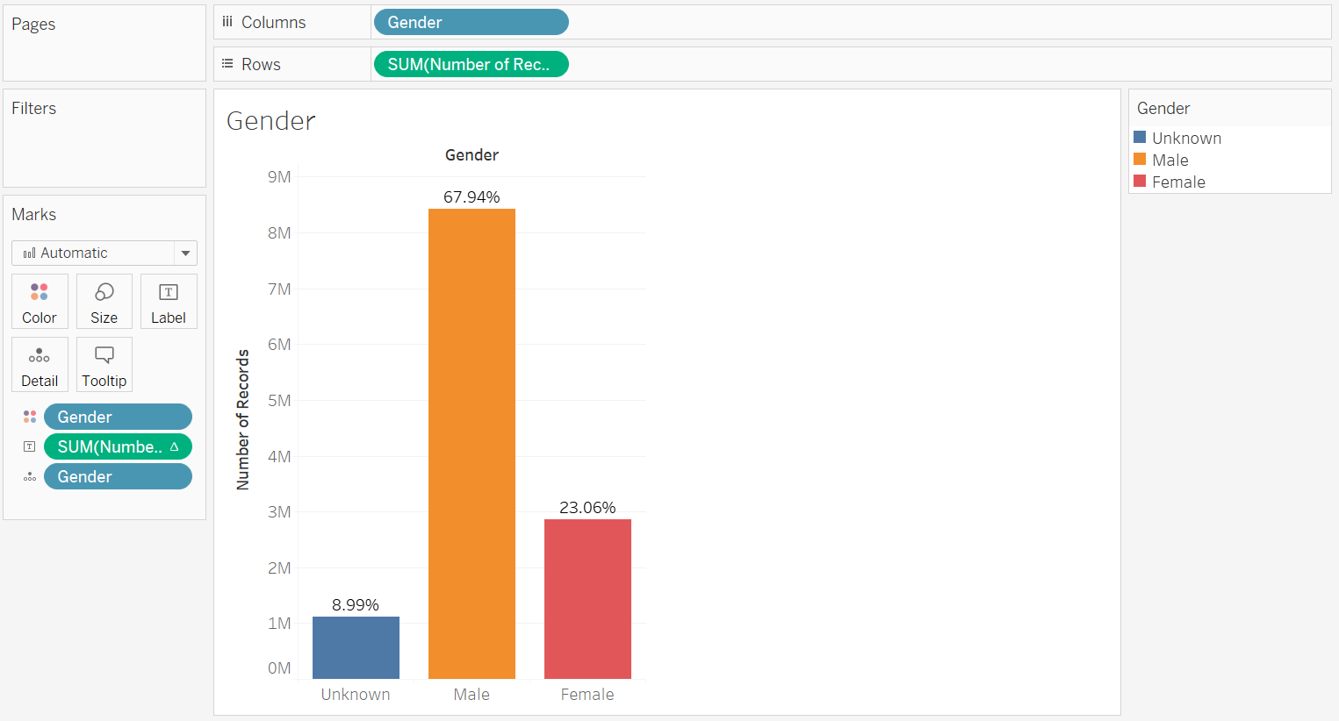

1. How effective has gender outreach been in increasing female ridership over the timespan?

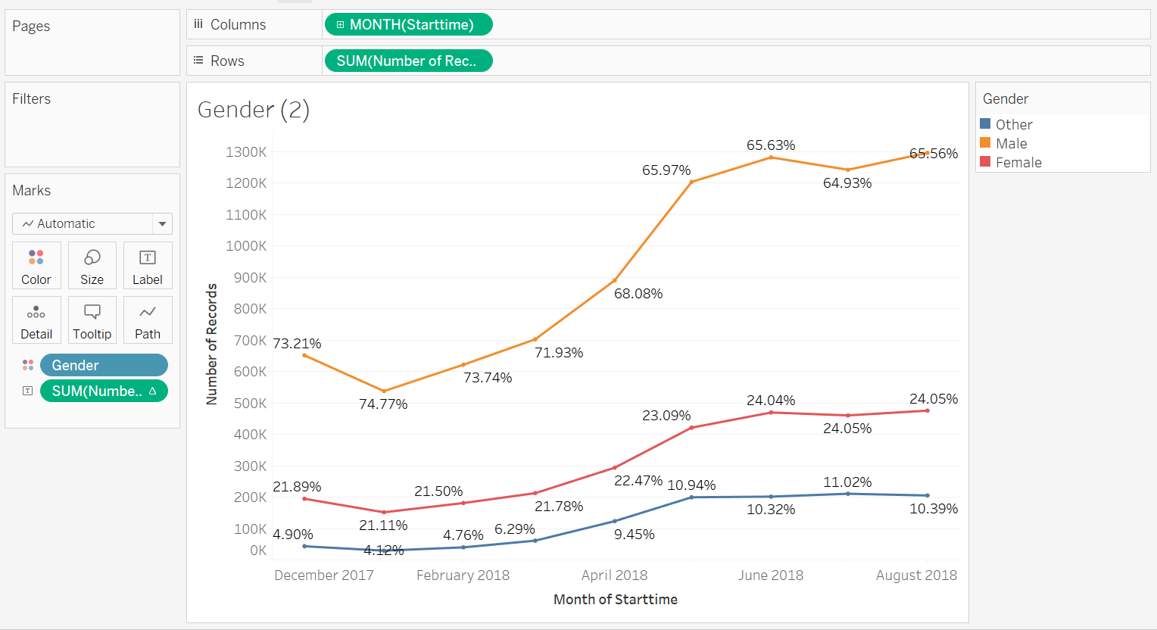

1. How does the average trip duration change by age?

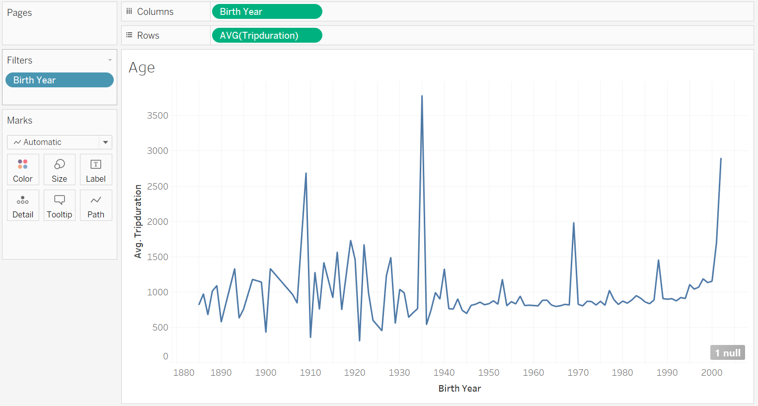

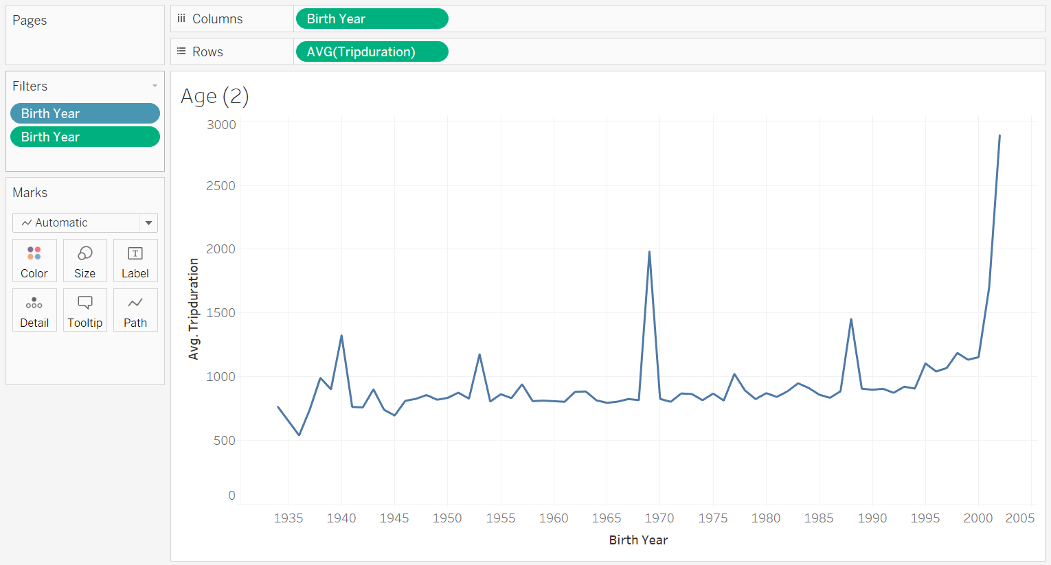

1. What is the average distance in miles that a bike is ridden?

Average of (trip duration / 3600 seconds/hour) \* 12 miles/hour comes out to 3.39 miles

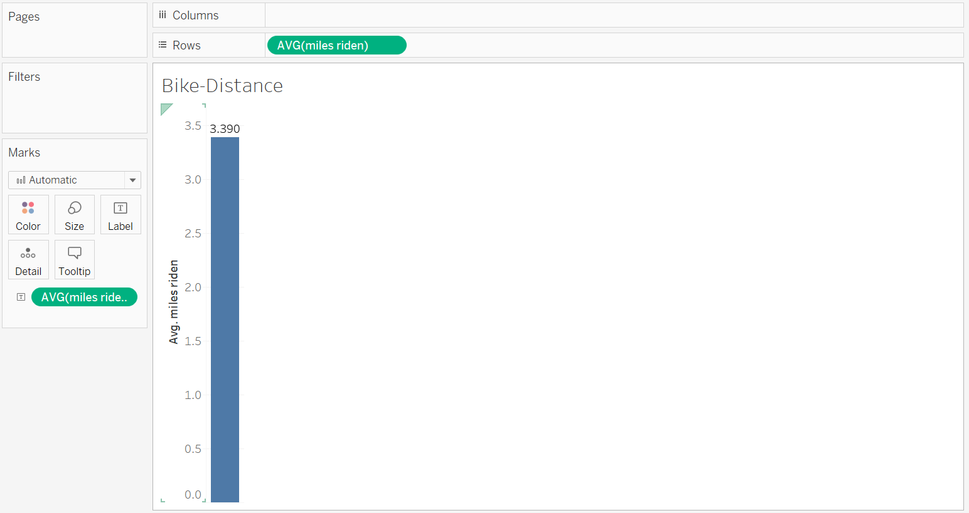

1. Which bikes (by ID) are most likely due for repair or inspection in the timespan?

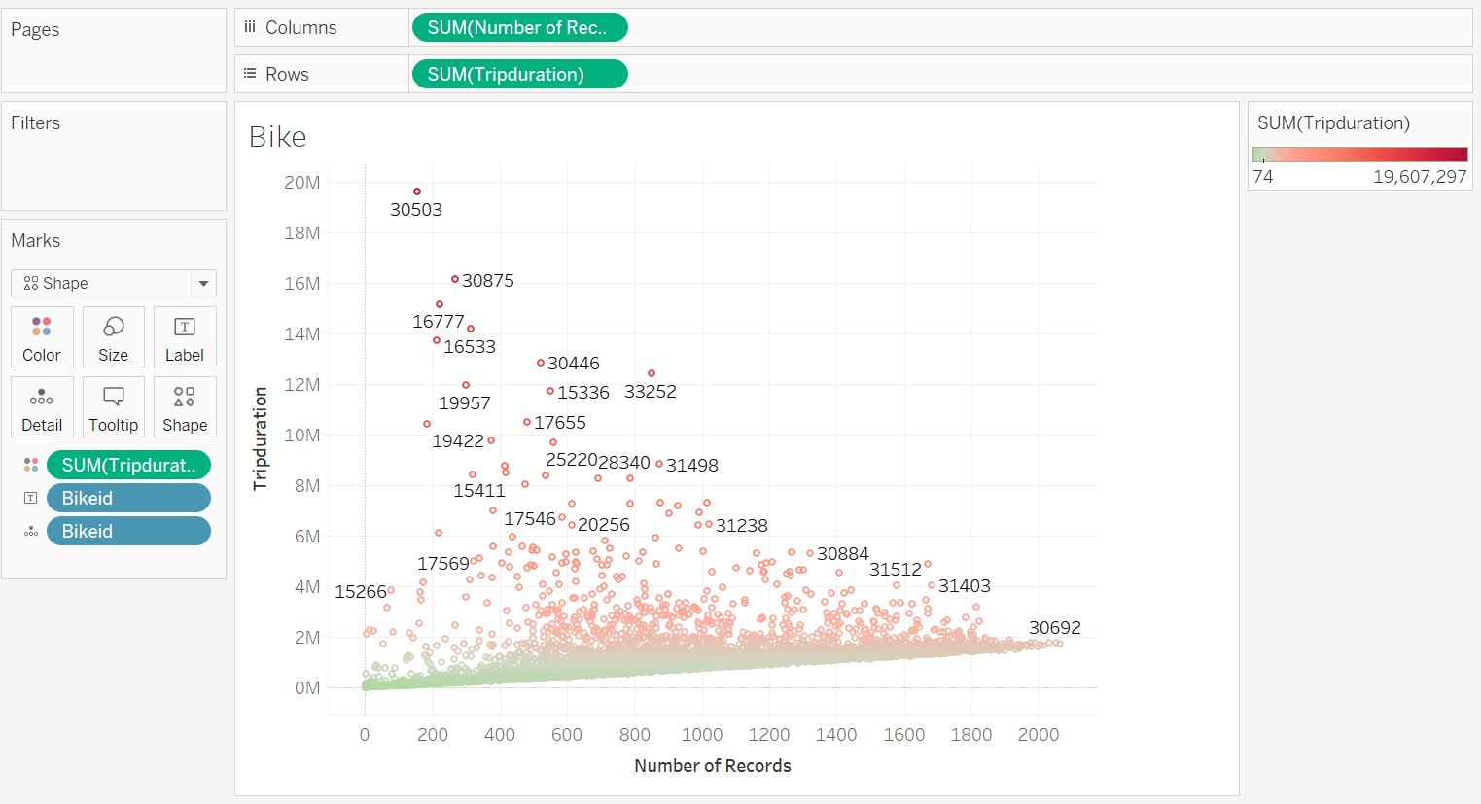

1. How variable is the utilization by bike ID?

